

**2021-2022 Fall Semester**

**Title: Algorithm Efficiency and Sorting**

**Author: Alper Mumcular**

**ID: 21902740**

**Section: 1**

**Assignment: 1**

**Description: Report**

**Question 1**

**a)**

1- T(n) = 3 T(n/3) + n

= 9 T(n/9) + 2n

= 27 T(n/27) + 3n

…

= 3k T(n/3k) + kn 3k = n => k = log3n

= n T(n/n) + n log3n

= n T(1) + n log3n

= O(n*log3n) = O(n*log2n)

2- T(n) = 2 T(n-1) + n2

= 4 T(n-2) + 2n2

= 8 T(n-3) + 3n2

…

= 2k T(n-k) + kn2 n = k + 1

=2n-1 T(1) + (n-1)*n2

= O(2n-1 + (n-1)*n2 ) = O(2n)

3- T(n) = 3 T(n/4) + n*logn

= 9 T(n/16) + 2*n*logn

= 27 T(n/64) + 3*n*logn

…

= 3k T(n/4k) + k*n*logn n = 4k => k = log2n

=3log4n T(1) + log4n*n*logn

= O(3log4n + log4n*n*logn) = O (n*logn*logn)

4- T(n) = 3 T(n/2) + 1

= 9 T(n/4) + 2

= 27 T(n/8) + 3

…

= 3k T(n/2k) + k n = 2k = > k = log2n

= 3log2n T(1) + log2n

= O( 3log2n + log2n ) => O(3log2n) = O(nlog23)=O(n2)

**b)**

**Bubble Sort:**

1- 5 6 8 4 10 2 9 1 3 7 |

2- 5 6 8 4 10 2 9 1 3 7 |

3- 5 6 8 4 10 2 9 1 3 7 |

4- 5 6 4 8 10 2 9 1 3 7 |

5- 5 6 4 8 10 2 9 1 3 7 |

6- 5 6 4 8 2 10 9 1 3 7 |

7- 5 6 4 8 2 9 10 1 3 7 |

8- 5 6 4 8 2 9 1 10 3 7 |

9- 5 6 4 8 2 9 1 3 10 7 |

10- 5 6 4 8 2 9 1 3 7 | 10

11- 5 6 4 8 2 9 1 3 7 | 10

12- 5 6 4 8 2 9 1 3 7 | 10

13- 5 4 6 8 2 9 1 3 7 | 10

14- 5 4 6 8 2 9 1 3 7 | 10

15- 5 4 6 2 8 9 1 3 7 | 10

16- 5 4 6 2 8 9 1 3 7 | 10

17- 5 4 6 2 8 1 9 3 7 | 10

18- 5 4 6 2 8 1 3 9 7 | 10

19- 5 4 6 2 8 1 3 7 | 9 10

20- 5 4 6 2 8 1 3 7 | 9 10

21- 4 5 6 2 8 1 3 7 | 9 10

22- 4 5 6 2 8 1 3 7 | 9 10

23- 4 5 2 6 8 1 3 7 | 9 10

24- 4 5 2 6 8 1 3 7 | 9 10

25- 4 5 2 6 1 8 3 7 | 9 10

26- 4 5 2 6 1 3 8 7 | 9 10

27- 4 5 2 6 1 3 7| 8 9 10

28- 4 5 2 6 1 3 7| 8 9 10

29- 4 5 2 6 1 3 7| 8 9 10

30- 4 2 5 6 1 3 7| 8 9 10

31- 4 2 5 6 1 3 7| 8 9 10

32- 4 2 5 1 6 3 7| 8 9 10

33- 4 2 5 1 3 6 7| 8 9 10

34- 4 2 5 1 3 6 | 7 8 9 10

35- 4 2 5 1 3 6 | 7 8 9 10

36- 2 4 5 1 3 6 | 7 8 9 10

37- 2 4 5 1 3 6 | 7 8 9 10

38- 2 4 1 5 3 6 | 7 8 9 10

39- 2 4 1 3 5 6 | 7 8 9 10

40- 2 4 1 3 5 | 6 7 8 9 10

41- 2 4 1 3 5 | 6 7 8 9 10

42- 2 4 1 3 5 | 6 7 8 9 10

43- 2 1 4 3 5 | 6 7 8 9 10

44- 2 1 3 4 5 | 6 7 8 9 10

45- 2 1 3 4| 5 6 7 8 9 10

46- 2 1 3 4| 5 6 7 8 9 10

47- 1 2 3 4| 5 6 7 8 9 10

48- 1 2 3 4| 5 6 7 8 9 10

49- 1 2 3| 4 5 6 7 8 9 10

50- 1 2 3| 4 5 6 7 8 9 10

51- 1 2 3| 4 5 6 7 8 9 10

52- 1 2| 3 4 5 6 7 8 9 10

53- 1 2| 3 4 5 6 7 8 9 10

54- 1| 2 3 4 5 6 7 8 9 10

55- |1 2 3 4 5 6 7 8 9 10

**Selection Sort:**

1- 5 6 8 4 10 2 9 1 3 7 | largest = 5

2- 5 6 8 4 10 2 9 1 3 7 | largest = 6

3- 5 6 8 4 10 2 9 1 3 7 | largest = 8

4- 5 6 8 4 10 2 9 1 3 7 | largest = 8

5- 5 6 8 4 10 2 9 1 3 7 | largest = 10

6- 5 6 8 4 10 2 9 1 3 7 | largest = 10

7- 5 6 8 4 10 2 9 1 3 7 | largest = 10

8- 5 6 8 4 10 2 9 1 3 7 | largest = 10

9- 5 6 8 4 10 2 9 1 3 7 | largest = 10

10- 5 6 8 4 10 2 9 1 3 7 | largest = 10

11- 5 6 8 4 7 2 9 1 3| 10 swap

12- 5 6 8 4 7 2 9 1 3| 10 largest = 5

13- 5 6 8 4 7 2 9 1 3| 10 largest = 6

14- 5 6 8 4 7 2 9 1 3| 10 largest = 8

15- 5 6 8 4 7 2 9 1 3| 10 largest = 8

16- 5 6 8 4 7 2 9 1 3| 10 largest = 8

17- 5 6 8 4 7 2 9 1 3| 10 largest = 8

18- 5 6 8 4 7 2 9 1 3| 10 largest = 9

19- 5 6 8 4 7 2 9 1 3| 10 largest = 9

20- 5 6 8 4 7 2 9 1 3| 10 largest = 9

21- 5 6 8 4 7 2 3 1| 9 10 largest = 9

22- 5 6 8 4 7 2 3 1| 9 10 swap

23- 5 6 8 4 7 2 3 1| 9 10 largest = 6

24- 5 6 8 4 7 2 3 1| 9 10 largest = 8

25- 5 6 8 4 7 2 3 1| 9 10 largest = 8

26- 5 6 8 4 7 2 3 1| 9 10 largest = 8

27- 5 6 8 4 7 2 3 1| 9 10 largest = 8

28- 5 6 8 4 7 2 3 1| 9 10 largest = 8

29- 5 6 8 4 7 2 3 1| 9 10 largest = 8

30- 5 6 1 4 7 2 3| 8 9 10 swap

31- 5 6 1 4 7 2 3| 8 9 10 largest = 5

32- 5 6 1 4 7 2 3| 8 9 10 largest = 6

33- 5 6 1 4 7 2 3| 8 9 10 largest = 6

34- 5 6 1 4 7 2 3| 8 9 10 largest = 6

35- 5 6 1 4 7 2 3| 8 9 10 largest = 7

36- 5 6 1 4 7 2 3| 8 9 10 largest = 7

37- 5 6 1 4 7 2 3| 8 9 10 largest = 7

38- 5 6 1 4 3 2| 7 8 9 10 swap

39- 5 6 1 4 3 2| 7 8 9 10 largest = 5

40- 5 6 1 4 3 2| 7 8 9 10 largest = 6

41- 5 6 1 4 3 2| 7 8 9 10 largest = 6

42- 5 6 1 4 3 2| 7 8 9 10 largest = 6

43- 5 6 1 4 3 2| 7 8 9 10 largest = 6

44- 5 6 1 4 3 2| 7 8 9 10 largest = 6

45- 5 2 1 4 3| 6 7 8 9 10 swap

46- 5 2 1 4 3| 6 7 8 9 10 largest = 5

47- 5 2 1 4 3| 6 7 8 9 10 largest = 5

48- 5 2 1 4 3| 6 7 8 9 10 largest = 5

49- 5 2 1 4 3| 6 7 8 9 10 largest = 5

50- 5 2 1 4 3| 6 7 8 9 10 largest = 5

51- 3 2 1 4| 5 6 7 8 9 10 swap

52- 3 2 1 4| 5 6 7 8 9 10 largest = 3

53- 3 2 1 4| 5 6 7 8 9 10 largest = 3

54- 3 2 1 4| 5 6 7 8 9 10 largest = 3

55- 3 2 1 4| 5 6 7 8 9 10 largest = 4

56- 3 2 1| 4 5 6 7 8 9 10 swap

57- 3 2 1| 4 5 6 7 8 9 10 largest = 3

58- 3 2 1| 4 5 6 7 8 9 10 largest = 3

59- 3 2 1| 4 5 6 7 8 9 10 largest = 3

60- 1 2| 3 4 5 6 7 8 9 10 swap

61- 1 2| 3 4 5 6 7 8 9 10 largest = 1

62- 1 2| 3 4 5 6 7 8 9 10 largest = 2

63- 1| 2 3 4 5 6 7 8 9 10 swap

64- 1| 2 3 4 5 6 7 8 9 10 largest = 1

65- |1 2 3 4 5 6 7 8 9 10

**c)**

The worst case is that the pivot divides the list of size n into two sublists of sizes 0 and n-1.

T(N) = T(N-1) + T(0) + N [ T(0) = 1 ]

= T(N-1) + N + 1

= T(N-2) + 2 (N+1)

= T(N-3) + 3 (N+1)

…

= T(N-k) + k (N+1) k = n

= T(N-N) + N (N+1)

= T(0) + N (N+1)

= O(1+N2+N) = O(N2) 🡪 Worst case.

**Question 2**

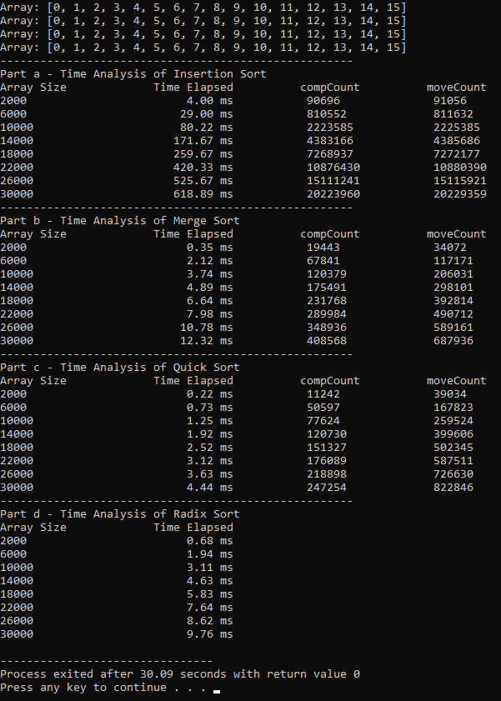

**Question 3**

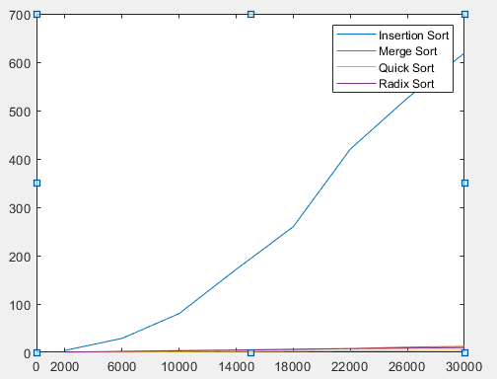

Figure 1: Graph of 4 Sorting Algorithms

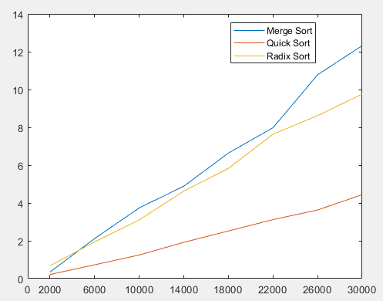

Figure 2: Graph of Sorting Algorithms Except Insertion Sort

**Comments**

**\***We can see that Insertion Sort requires much more time than the other three sorting algorithms in Graph 1.

**\***Graph of Insertion Sort is similar to O(n2), elapsed time of Merge Sort is similar to O(n*logn), elapsed time of Quick Sort is similar to O(n*logn), elapsed time of Radix Sort is similar to O(n). According to the graph, making comments of other sorting algorithms except Insertion Sort is hard.

**\***Theoretically, Radix Sort should be the most efficient sorting algorithm, but empirically, Quick Sort requires less time than the others.

**\***According to the experiment, Quick Sort is better than the Merge Sort whereas both are O(n*logn). The reason of this can be Merge Sort is not an in-place algorithm and requires extra memory. Creating extra memory will increase the elapsed time in Merge Sort.

**Question**: How would the time complexity of your program change if you applied the sorting algorithms to an array of increasing numbers instead of randomly generated numbers?

**\*** Insertion Sort: Array is already sorted. Therefore, inner loop will not be executed. For this reason, Insertion Sort will be O(n). In my program, the elapsed time of Insertion sort will decrease.

**\*** Merge Sort: Best case of Merge Sort is O(n*logn). Therefore, elapsed time will not be affected too much, but it will decrease because in merge operations, one array will be placed in the original array then all elements in the other array will be placed in the original array.

**\*** Quick Sort: This will be the worst case of Quick Sort because pivot element divides the list of size n into two sublists of sizes zero and n-1. Therefore, time complexity of Quick Sort will become O(n2). Hence, the running time of Quick Sort will increase.

**\*** Radix Sort: Time complexity of Radix Sort is O(n). The elapsed time in Radix Sort will not be affected too much because Radix Sort does not use key comparisons to sort an array.